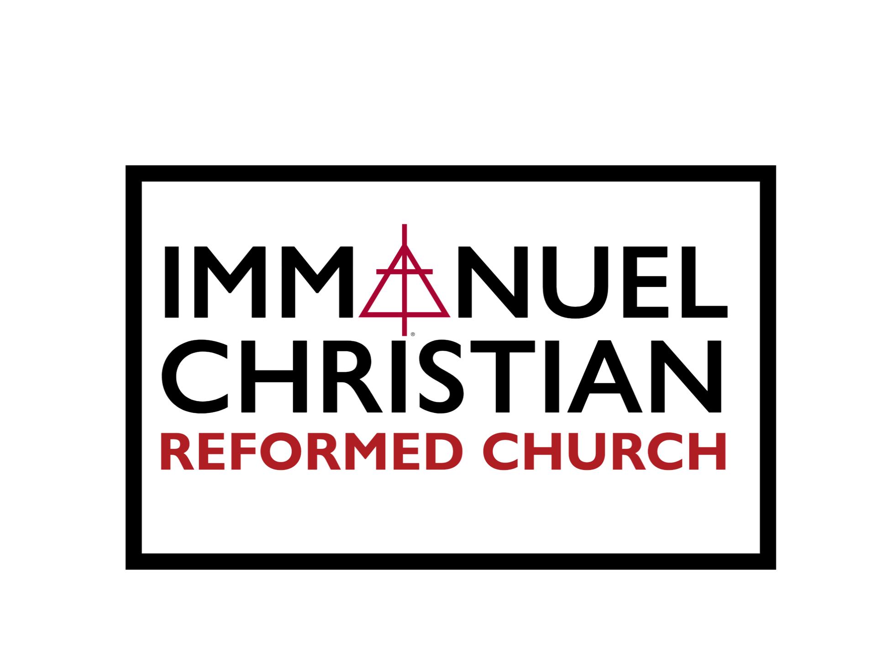

Welcome to
Immanuel Christian Reformed Church

We are a community of believers…
directed by God’s Word and Spirit…
seeking to share Christ’s love with our neighbors…
growing together in faith.

Sunday Evening Fellowship
March 15, 2026

Prelude
Welcome
*Song of Praise:
“Before the Throne of God Above”
Testimony: An Answer to Prayer – Scott Belgrave
Congregational Prayer
Hymn Sing
*Nicene Creed
Song of Assurance:
“Be Thou My Vision”
Sermon:
“Where is God?”
Esther 1:1-2
Song of Conclusion:
“It Is Well with My Soul”

