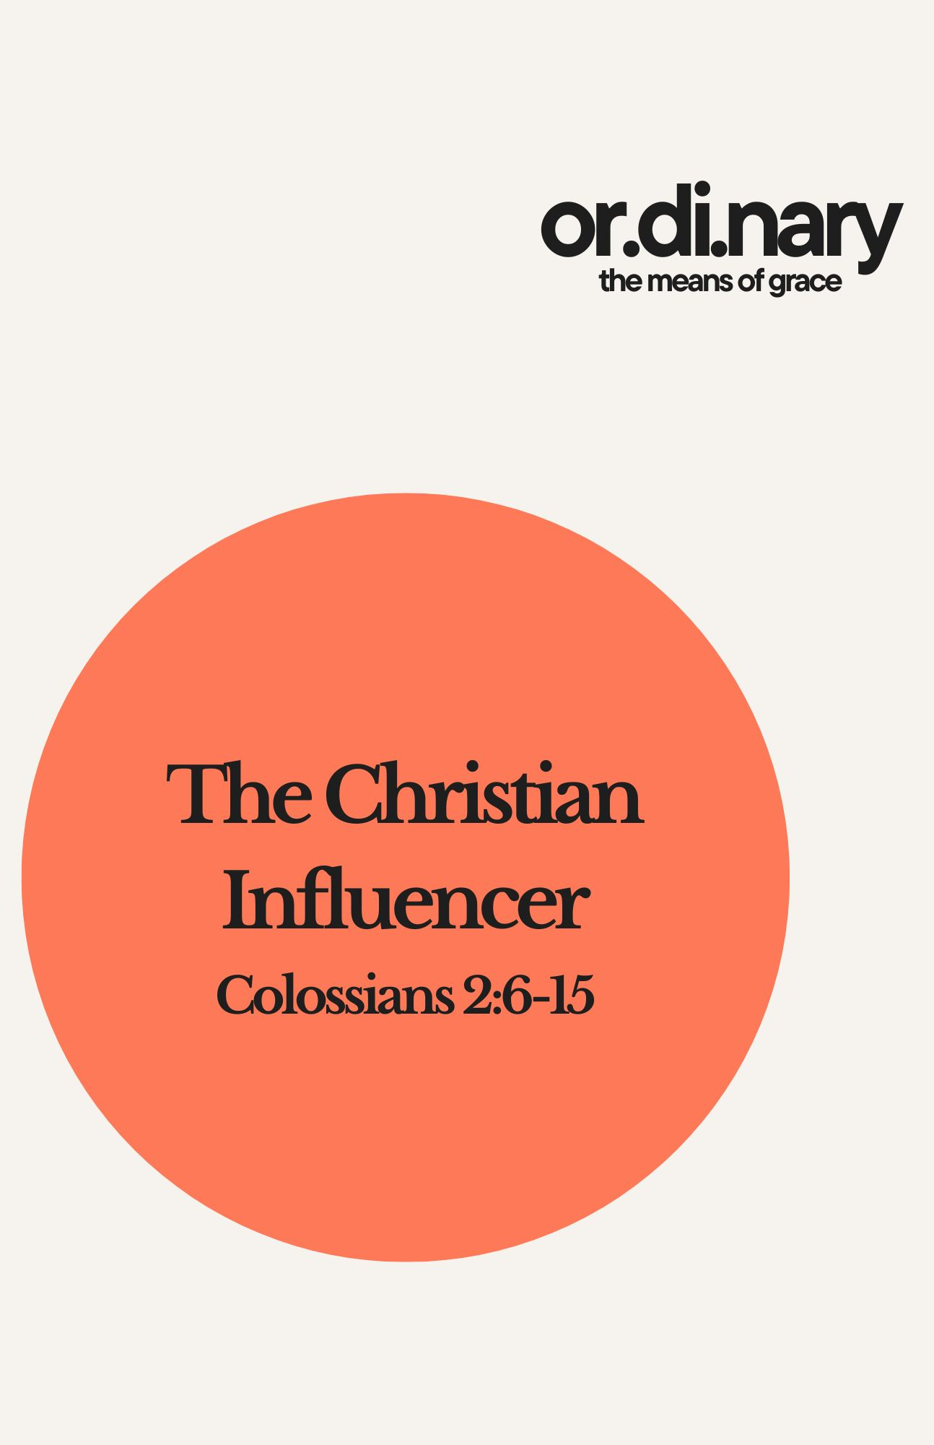

Baptism – The Christian Influencer
Scripture: Colossians 2:6–15

Theme
God uses ordinary means of grace to communicate and strengthen faith. Baptism is not merely a past event but a present, God-given influence that shapes how Christians live.

Why Baptism Matters
Key Question: When was the last time you seriously reflected on your baptism?

Colossians 2: The Big Picture
- Growth in holiness is inseparable from right knowledge of Christ.

Encouragement #1: Live Out Your Faith (vv. 6–7)

Result: A life abounding in thanksgiving.

Encouragement #2: Be Careful with Influencers (v. 8)

Modern Examples:
- The American Dream (human tradition)
- Expressive Individualism (demonic-elemental spirits)
These are not according to Christ. They promise satisfaction but deliver captivity.

Encouragement #3: Live into your Union with Jesus Christ (vv. 9-15)

1. Jesus Is the God-Man (v. 9)

2. Jesus Is Our Satisfaction (v. 10)

3. Jesus Gives a New Identity of Freedom (vv. 11–15)

Circumcision and Baptism and Christ
- Circumcision anticipated the removal of sin.
- It pointed forward to Christ’s death.
- Jesus bore the cutting away of sinful flesh for sinners.
- Baptism replaces circumcision as the covenant sign.
- It signifies participation in Christ’s death and resurrection.
- Baptism is bloodless because Christ’s blood was shed once for all.

Baptism: A New Identity of Freedom (vv. 13–15)
- Dead → Made alive in Christ
- Debt → Forgiven
- Condemnation → Nailed to the cross
- Enemies → Defeated and shamed
- Baptism declares God’s action toward you.

Main Point
The way we live worthily is by letting the reality of our baptism be our influencer.

Improving Our Baptism (WLC Q. 167)
Baptism is to be lived into throughout the Christian life, especially in times of temptation.
- Humbling ourselves for sin
- Growing in assurance of forgiveness and adoption
- Drawing strength from Christ’s death and resurrection
- Living by faith and pursuing holiness
- Walking in brotherly love within the church

